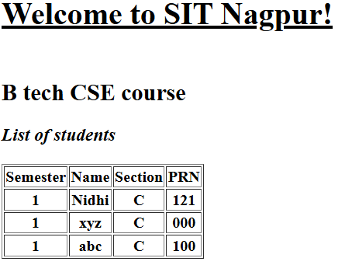
Practical 2 HTML
<!DOCTYPE html>
<html>
<head>
<title>Page title</title>
</head>
<body>
<h1><b><u>Welcome to SIT Nagpur!</u></b></h1>
<h2><br>B tech CSE course<br></h2>
<h3><i>List of students</i></h3>

<table border="1">
<tr>
<th>Semester</th>
<th>Name</th>
<th>Section</th>
<th>PRN</th>
</tr>
<tr>
<th>1</th>
<th>Nidhi</th>
<th>C</th>
<th>121</th>
</tr>
<tr>
<th>1</th>
<th>xyz</th>
<th>C</th>
<th>000</th>
</tr>
<tr>
<th>1</th>
<th>abc</th>
<th>C</th>
<th>100</th>
</tr>
</table>
</body>
</html>

